**EX NO:4a Date:**

**NAME:S.Subramanian**

**REG.NO:230701349**

**Conduct task analysis for an app (e.g., online shopping) and**

**document user flows. Create corresponding wireframes using**

**Lucidchart**

**AIM:**

To understand and document the steps a user takes to complete the main tasks within

an online shopping app.

Tool Link: https://www.lucidchart.com/pages/

**PROCEDURE:**

**Step 1: Assigning Tasks**

1. Browsing Products

2. Searching for a Specific Product

3. Adding a Product to the Cart

4. Checking Out

**Step 2: Document User Flows**

**1. Browsing Products**

1. Home Screen: User lands on the home page with product categories.

2. Product Categories: User taps on a category to view products.

3. Product List: User scrolls through the product list.

4. Product Details: User taps on a specific product to see details.

Home Screen -&gt; Product Categories -&gt; Product List -&gt; Product Details

**2. Searching for a Specific Product**

1. Search: User taps the search bar or icon.

2. Enter Query: User types the product name or keyword.

3. Search Results: User reviews matching items.

4. Product Details: User taps on a specific product to see details.

Search -&gt; Enter Query -&gt; Search Results -&gt; Product Details

**3. Adding a Product to the Cart**

1. View Products: User browses or searches for a product.

2. Product Details: User taps on the product to see more info.

3. Add to Cart: User clicks &quot;Add to Cart&quot;.

View Products -&gt; Product Details -&gt; Add to Cart

**4. Checking Out**

1. Open Cart: User taps on the cart icon.

2. Review Cart: User checks all products.

3. Proceed to Checkout: User clicks &quot;Checkout&quot;.

4. Enter Shipping Info: User provides shipping details.

5. Enter Payment Info: User provides payment details.

6. Place Order: User clicks &quot;Place Order&quot;.

Open Cart -&gt; Review Cart -&gt; Proceed to Checkout -&gt; Enter Shipping Info -&gt; Enter

Payment Info -&gt; Place Order

**Step-by-Step Procedure to Create User Flows in Lucidchart**

**1. Create a New Document**

● Go to Lucidchart and sign in or sign up if you don&#39;t have an account.

● Click on + Document or Create New Diagram.

**2. Select a Template**

● You can start with a blank document or select a flowchart template.

● For this example, let&#39;s start with a blank document.

**3. Add Shapes for Each Step**

● Drag and drop shapes from the left sidebar to represent different steps in your

flow (e.g., rectangles for actions, diamonds for decisions).

● Name each shape based on the steps from the task analysis:

○ Login/Register

○ Browsing Products

○ Adding Products to Cart

○ Managing Cart

○ Checkout Process

○ Tracking Orders

**4. Connect the Shapes**

● Use connectors to link the shapes, indicating the flow from one step to the next.

● Add arrows to show the direction of the flow.

**5. Add Details to Each Step**

● Double-click on each shape to add text describing the action or decision.

● For example, for the &quot;Login/Register&quot; step, you might add:

○ Open the app

○ Click on &quot;Sign Up&quot; or &quot;Login&quot;

○ Enter details (username, email, password)

○ Click &quot;Submit&quot;

○ Verification through email or phone (if required)

○ Redirect to the home screen upon successful login

**6. Use Different Shapes for Different Actions**

● Use rectangles for general actions.

● Use diamonds for decision points (e.g., &quot;Is the user logged in?&quot;).

● Use ovals for start and end points.

**7. Customize and Organize Your Flowchart**

● Arrange the shapes and connectors logically.

● Use different colors to distinguish between types of steps or user roles.

● Group related steps into sections for better clarity.

**8. Review and Save Your Flowchart**

● Review the flowchart to ensure all steps are included and connected correctly.

● Save your flowchart by clicking on File -&gt; Save.

**9. Share and Collaborate**

● Click on the Share button to collaborate with others.

● You can also export your flowchart as an image or PDF for presentation

purposes.

**Example Flowchart Breakdown:**

Login/Register Flow

● Steps:

○ Open the app

○ Click on &quot;Login&quot; or &quot;Register&quot;

○ Enter details

○ Verify (if required)

○ Redirect to the home screen

**Browse and Search Flow**

● Steps:

○ Navigate to categories or use search bar

○ Apply filters/sorting options

○ View product details

**Add to Cart Flow**

● Steps:

○ View product details

○ Select options (size, color, quantity)

○ Add product to cart

**Checkout Flow**

● Steps:

○ Review cart

○ Proceed to checkout

○ Enter shipping information

○ Select payment method

○ Confirm and place order

**Order Tracking Flow**

● Steps:

○ Navigate to &quot;My Orders&quot;

○ Select order to track

○ View tracking details

**OUTPUT:**

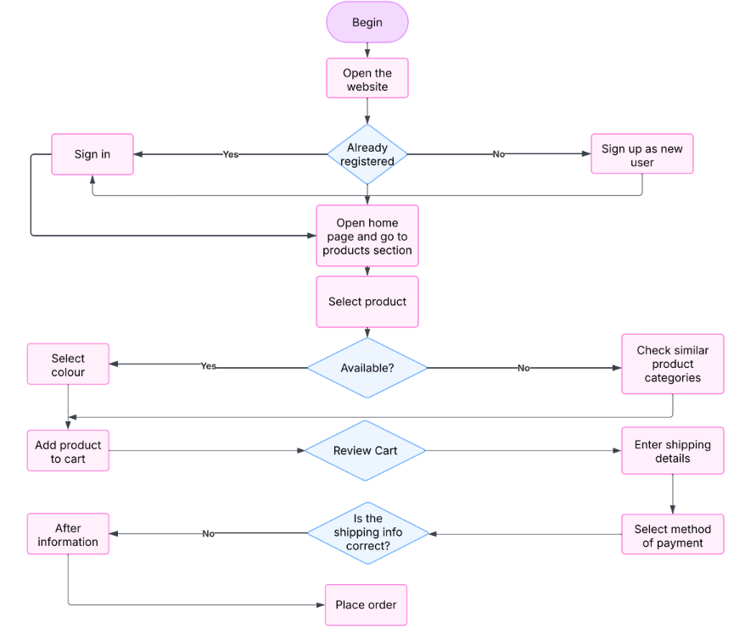

**RESULT:**

Hence , to understand & document the steps a user takes to complete the tasks in a shopping app using Lucidchart has been done successfully